**B.M.S. COLLEGE OF ENGINEERING BENGALURU**

Autonomous Institute, Affiliated to VTU



Lab Record

**Object-Oriented Modeling – 23CS5PCOOM**

*Submitted in partial fulfillment for the 5th Semester Laboratory*

Bachelor of Engineering

in

Computer Science and Engineering

*Submitted by:*

**BHOOMIKA M**

**1BM23CS068**

Department of Computer Science and Engineering

B.M.S. College of Engineering

Bull Temple Road, Basavanagudi, Bangalore 560 019

August 2025-December 2025

# **B.M.S. COLLEGE OF ENGINEERING**

**DEPARTMENT OF COMPUTER SCIENCE AND ENGINEERING**



## **CERTIFICATE**

This is to certify that the Object-Oriented Modeling(23CS5PCOOM) laboratory has been carried out by **BHOOMIKA M(1BM23CS068)** during the 5th Semester August 2025-December 2025.

Signature of the Faculty Incharge:

[Vikranth B.M](https://bmsce.ac.in/home/facultyProfile/52/Vikranth-BM)

Assistant Professor

Department of Computer Science and Engineering

B.M.S. College of Engineering, Bangalore

Table of Contents

|  |
| --- |
| 1. Hotel Management System |
| 2. Credit Card Processing |
| 3. Library Management System |
| 4. Stock Maintenance System |
| 5. Passport Automation System |

1. **Hotel Management System**

**Problem statement :**

A hotel needs a computerized system to streamline its daily operations, improve customer experience, and reduce manual workload. Currently, most tasks such as room booking, check-in/check-out, staff allocation, and bill generation are handled manually, which leads to errors, delays, and difficulty in maintaining records.

The Hotel Management System (HMS) should automate all major hotel activities and maintain accurate data in a structured way. The system must allow receptionists, managers, and customers to efficiently perform their respective tasks.

**SRS-Software Requirements Specification**

**1. Introduction**

**1.1 Purpose**

The purpose of this SRS document is to define the complete set of requirements for the Hotel Management System. It ensures a shared understanding between developers, management, and stakeholders about what the system will deliver. This document also establishes a base for design, development, and testing activities throughout the project lifecycle.

**1.2 Scope**

The system will automate hotel operations such as room reservations, guest check-in/check-out, room status updates, billing, and reporting. It will support hotel staff, administrators, and customers with accurate, real-time information. The scope also includes integration with booking platforms and secure payment methods required for operational efficiency.

**1.3 Overview**

The Hotel Management System provides a centralized platform for managing room availability, guest records, and financial operations. It is designed to reduce manual errors, improve service quality, ensure faster operations, and maintain all hotel data digitally.

**2. General Description**

The system will serve receptionists, managers, and administrators by providing a simple interface for routine tasks. It manages multiple room categories, guest profiles, service charges, and reservations. The system ensures smooth workflows by updating all modules in real time. It supports role-based access control, cloud storage, and multi-device access. The solution aims to increase operational efficiency and enhance customer satisfaction.

**3. Functional Requirements**

**3.1 Reservation Management**

* Users can create, modify, and cancel reservations.
* The system checks room availability based on date, room type, and occupancy.
* Reservation confirmations are automatically generated and sent via email/SMS.
* Supports advance booking, group booking, and reservation history tracking.

**3.2 Room Management**

* Maintains room information including type, price, and capacity.
* Updates real-time room status: Available, Occupied, Cleaning, or Maintenance.
* Assigns rooms automatically based on guest preferences and availability.
* Notifies housekeeping when rooms need cleaning or when guests check out.

**3.3 Guest Management**

* Stores guest personal details, identity proofs, preferences, and booking history.
* Supports fast check-in and check-out with digital verification.
* Maintains guest service usage data for billing purposes.
* Allows storing special notes for VIP or repeat guests.

**3.4 Billing & Invoicing**

* Generates bills automatically based on stay duration and services used.
* Supports UPI, cash, card, online wallet, and corporate billing.
* Provides printable and downloadable invoices.
* Maintains financial logs and tax calculations.

**3.5 Reporting**

* Generates daily, weekly, and monthly reservation and revenue reports.
* Provides room occupancy statistics and staff activity logs.

**4. Interface Requirements**

**4.1 User Interface**

* Clean and user-friendly dashboard with room status view, booking forms, and billing windows.
* Responsive UI accessible on desktops, tablets, and mobile devices.
* Different dashboards for admin, manager, and receptionist.
* Provides search functionality for guests, bookings, and rooms.

**4.2 Integration Interfaces**

* Integration with payment gateways for secure transactions.
* API support for integration with booking sites like Booking.com or OYO.
* Can integrate with hotel hardware such as printers, card readers, and POS systems.

**5. Performance Requirements**

* The system should respond to user actions (booking, billing, search) within 2 seconds.
* Must support at least 1000 concurrent users during peak seasons.
* Real-time updates must reflect room status changes instantly.
* System uptime should be at least 99% to avoid service interruptions.

**6. Design Constraints**

* Must run on standard hotel computers, printers, POS machines, and mobile devices.
* Requires a relational database such as MySQL for consistent data handling.
* Backend should be built using Java/Spring Boot, Python Django, or equivalent frameworks.
* Should operate smoothly with low-speed internet within hotel premises.

**7. Non-Functional Attributes**

**7.1 Security -**Must include authentication, role-based access control, encrypted data storage, and secure payment handling.

**7.2 Reliability-** The system should provide consistent performance with minimal downtime and support data backup and recovery.

**7.3 Scalability -**Should support increasing guests, rooms, and concurrent staff without affecting performance.

**7.4 Portability -**The software must run on multiple operating systems and device types with minimal setup.

**7.5 Usability -**Easy-to-understand interface with clear navigation for staff of all skill levels.

**7.6 Reusability**

Uses modular components that allow future upgrades and new features to be added easily.

**7.7 Compatibility -**Compatible with common web browsers, hotel hardware, and standard network environments.

**7.8 Data Integrity -**Ensures accurate, consistent, and complete data across all interconnected modules.

**8. Preliminary Schedule and Budget**

The project is estimated to take 6 months including planning, analysis, design, development, testing, and deployment phases. The approximate budget is $100,000, which includes hardware support, software development, third-party integrations, and maintenance.

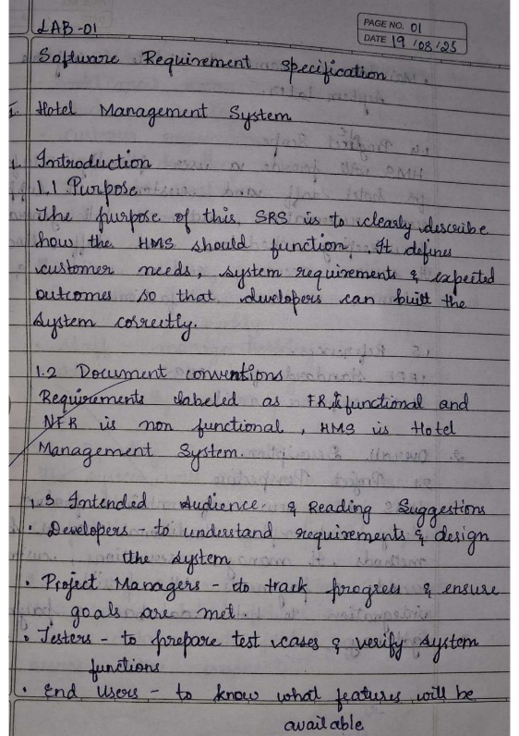 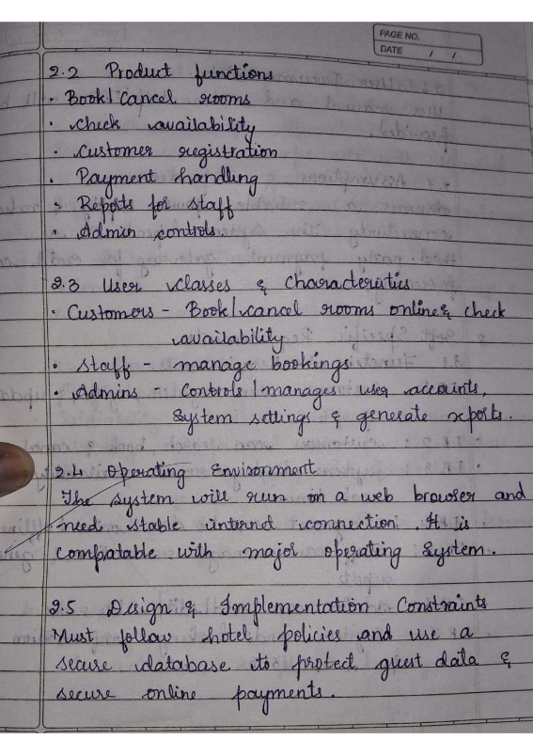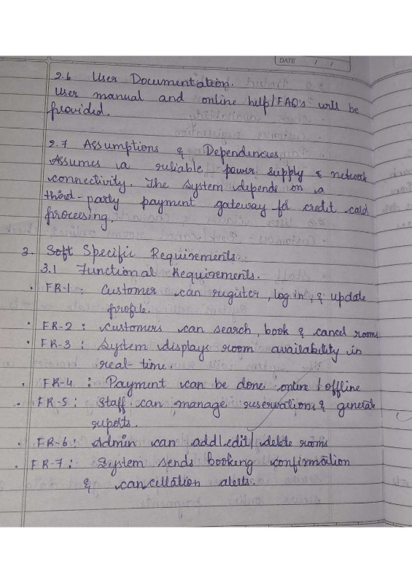 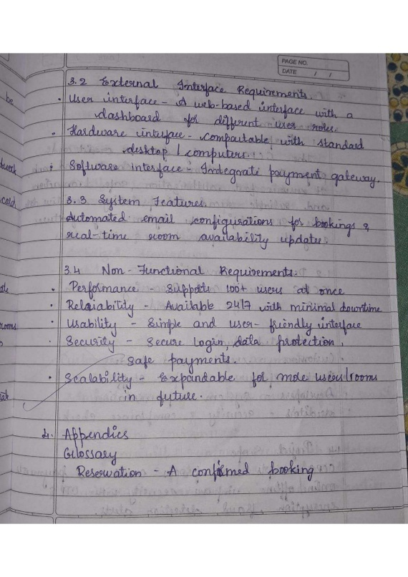

**Class Diagram**

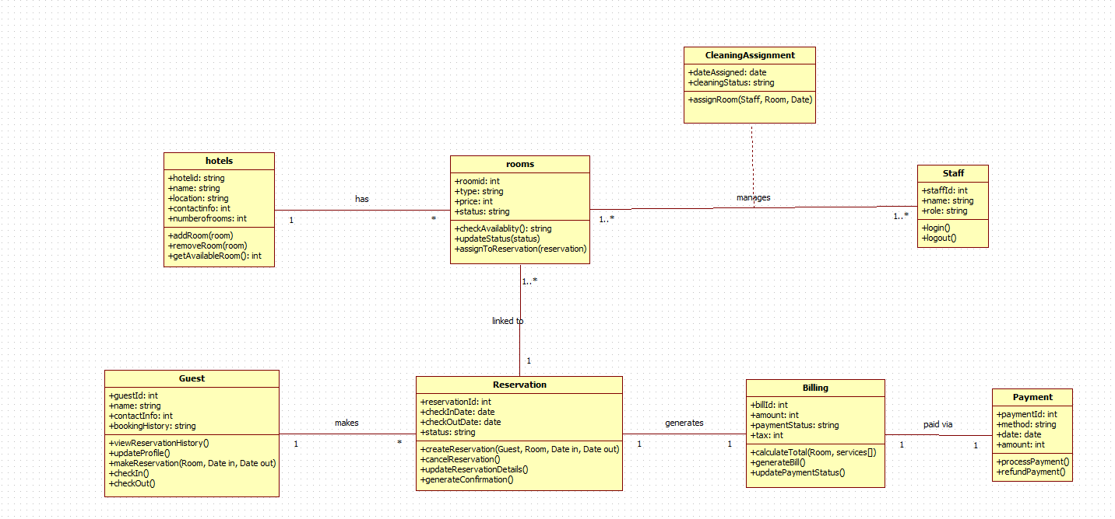

|  |  |  |  |
| --- | --- | --- | --- |
| **Class Name** | **Purpose / What the Class Does** | **Relationship With Other Classes** | **Description of Relationship** |
| Hotel | Stores hotel details like name, location, and total rooms. Manages adding, removing, and listing available rooms. | 1 → * Rooms | One hotel has many rooms. The hotel acts as the container for all rooms in the system. |
| Room | Represents each room with details like type, price, availability, and assignment. Handles booking, status updates, and availability checks. | * → 1 Hotel * → 1 Reservation | Each room belongs to one hotel. A room can be linked to multiple reservations over time, but only one active reservation at a time. |
| Guest | Stores guest information, contact details, and booking history. Responsible for making reservations and performing check-in/check-out. | 1 → * Reservation | A guest can make many reservations, but each reservation is linked to only one guest. |
| Reservation | Handles the full reservation process including booking dates, status, and confirmation. Represents room booking by a guest. | * → 1 Guest * → 1 Room 1 → 1 Billing | Reservation is the central link: one guest + one room = one reservation. Each reservation generates exactly one bill. |
| Billing | Generates bills for reservations including room charges, services, and taxes. Updates payment status. | 1 → 1 Reservation 1 → * Payment | One reservation produces one bill. A bill can have multiple payments (partial payments allowed). |
| Payment | Handles payment methods (cash, card, UPI) and transaction amounts. Processes and refunds payments. | * → 1 Billing | Payments belong to a bill. Multiple payments can be made toward one bill. |
| Staff | Represents hotel employees, including receptionists and cleaning staff. Handles login and assigned duties. | 1 → * CleaningAssignment | One staff member can have many cleaning assignments. Staff manages room status indirectly through cleaning tasks. |
| CleaningAssignment | Stores cleaning details like assigned date, status, and staff-room mapping. Handles room cleaning tasks. | * → 1 Staff * → 1 Room | A cleaning assignment links one staff member to one room at a time. Over time, many assignments occur for each room and staff member. |

**State Diagram:**

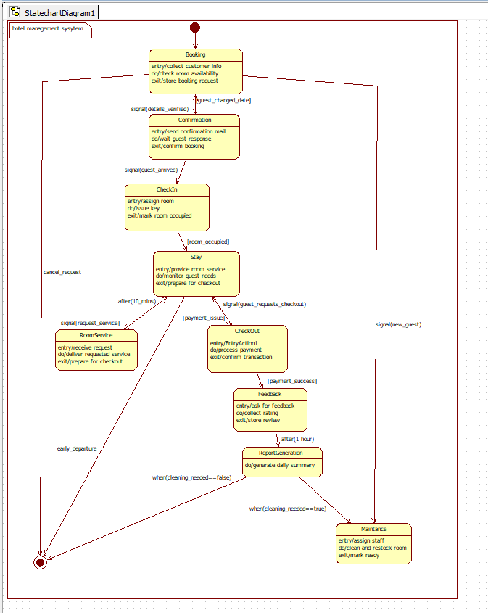

|  |  |  |  |  |
| --- | --- | --- | --- | --- |
| **State** | **Description (What Happens)** | **Trigger / Event** | **Next State** | **Explanation** |
| **Booking** | Collects customer info, checks availability, stores booking request. | details_verified | Confirmation | User begins the process by booking a room. |
| **Confirmation** | Sends confirmation mail, waits for response, finalizes booking. | guest_arrived | CheckIn | Confirms booking and prepares room allocation. |
| **CheckIn** | Assigns room, issues key, marks room as occupied. | room_occupied | Stay | Guest arrives and check-in is completed. |
| **Stay** | Guest stays in hotel; room service and monitoring happen. | guest_requests_checkout | CheckOut | Active stay phase. Guest can request service or check out. |
| **RoomService** | Staff provides requested services. | request_service | Stay | Temporary state for service, then returns to Stay. |
| **CheckOut** | Processes payment and closes stay. | payment_success | Feedback | Guest initiates checkout. |
| **Feedback** | Collects guest feedback and rating. | after(1 hour) | ReportGeneration | Optional step after checkout. |
| **ReportGeneration** | Generates daily summary reports. | cleaning_needed == true | Maintenance | Final reporting phase. |
| **Maintenance** | Cleans and prepares room for next guest. | cleaning_needed == false | Booking | Final reset before next guest cycle. |

**Use-Case Diagram:**

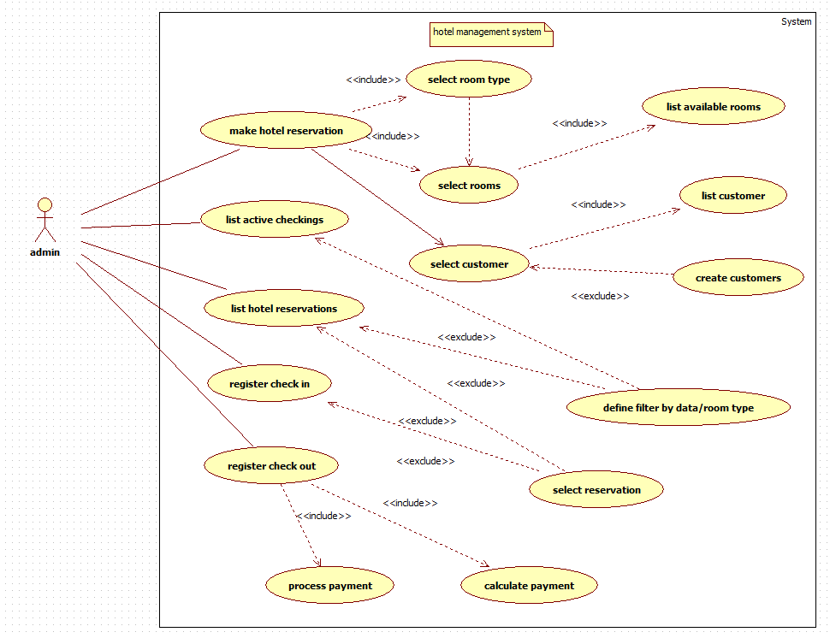

TABLE 1: Actors and Their Responsibilities

|  |  |
| --- | --- |
| **Actor** | **Description / Responsibilities** |
| Admin | The main user of the system. Responsible for managing reservations, customer records, check-ins, check-outs, viewing room availability, processing payments, and handling all booking-related operations. |

TABLE 2: Use Cases, Purpose, and Relationships

|  |  |  |  |  |
| --- | --- | --- | --- | --- |
| **Use Case** | **What It Does** | **Actor Involved** | **Relationship (Include / Extend)** | **Explanation of Relationship** |
| Make hotel reservation | Creates a new reservation for a customer | Admin | Includes → Select room type, Select rooms, Select customer | Reservation requires selecting room type → available rooms → customer. |
| Select room type | Filters rooms based on type (AC, Deluxe, etc.) | Admin | Included in Make reservation | Must be done before selecting specific rooms. |
| Select rooms | Chooses a room based on availability | Admin | Includes → List available rooms | Requires showing all available rooms. |
| List available rooms | Displays all free rooms that match date/type | Admin | Included | Automatically triggered during room selection. |
| Select customer | Picks a customer for the booking | Admin | Includes → List customers Extends → Create customers | If customer doesn’t exist, admin creates one. |
| List customer | Shows all existing customers | Admin | Included | Called when selecting a customer. |
| Create customers | Adds a new customer to the system | Admin | Extends Select customer | Optional step only when there’s no existing record. |
| List active check-ins | Shows all checked-in guests | Admin | — | Independent monitoring function. |
| List hotel reservations | Displays all reservations | Admin | Extends → Define filter | Admin can filter by room type/date. |
| Define filter | Filters reservations | Admin | Extends List hotel reservations | Optional when searching. |
| Register check-in | Marks guest as checked-in | Admin | Extends → Select reservation | Used to complete arrival process. |
| Register check-out | Completes guest stay | Admin | Includes → Process payment | Checkout always needs payment. |
| Process payment | Handles billing | Admin | Includes → Calculate payment | Requires cost computation. |
| Calculate payment | Computes booking charges | Admin | Included | Mandatory part of payment processing. |
| Select reservation | Selects reservation to manage | Admin | Extends other flows | Used in check-in, check-out, review. |

**Sequence diagram**

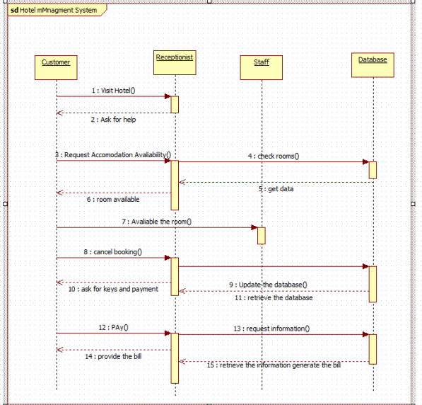

The sequence diagram shows the interaction between the customer, receptionist, staff, and

database during a hotel booking process. The customer visits the hotel, requests accommodation, and the receptionist checks room availability through the staff and database. Once availability is confirmed, the customer can proceed to book or cancel. The receptionist updates the database,

collects payment, and requests billing information. Finally, the receptionist provides the bill to the customer.

**Acitivity diagram**

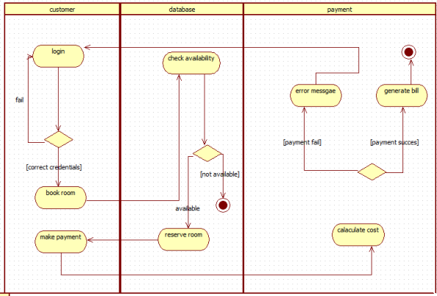

The activity diagram shows the steps a customer follows to book a room in the hotel system. The customer logs in, and the database checks room availability. If a room is available, the customer proceeds to book and make a payment. The payment system calculates the cost and either

generates the bill for a successful payment or shows an error message if the payment fails.

1. **Credit Card Processing**

**Problem statement :**

The existing manual and semi-automated credit card processing methods often lead to delays, security risks, and inconsistencies in transaction approvals. Financial institutions and merchants face challenges such as fraud detection, slow authorization response, and lack of real-time monitoring. A secure and efficient Credit Card Processing System is required to automate card verification, authorize transactions instantly, detect fraudulent activities, and ensure compliance with financial security standards. The system should enable smooth communication between merchants, banks, and payment networks to ensure fast, reliable, and secure payment processing.

**SRS-Software Requirements Specification**

**1. Introduction**

**1.1 Purpose**

The purpose of this SRS is to define all requirements for the Credit Card Processing System, ensuring secure card validation, transaction authorization, and fraud prevention. It serves as a foundation for developers, testers, and stakeholders to understand expected system behavior and technical constraints.

**1.2 Scope**

The system handles card verification, payment authorization, settlement processing, refunds, transaction logs, and fraud alerts. It connects merchants, payment gateways, and banks to facilitate seamless and secure financial transactions.

**1.3 Overview**

This system ensures quick, reliable, and compliant credit card processing while reducing risks associated with fraud. It provides dashboards for banks and merchants, supports large-scale transactions, and ensures secure communication with external financial networks.

**2. General Description**

The system acts as an intermediate layer between customer card data, merchant terminals, and banking servers. It validates card details, approves transactions, and records financial activities securely. The system maintains high reliability through redundancy, real-time processing, and auditing. User-friendly dashboards allow merchants and bank officials to monitor transactions, settlement cycles, and fraud alerts.

**3. Functional Requirements**

**3.1 Card Verification**

* Validates card number (Luhn check), expiry date, CVV, and cardholder information.
* Confirms card status through issuer bank (active, blocked, stolen, expired).
* Performs optional OTP or two-factor authentication for added security.

**3.2 Transaction Processing**

* Handles full payments, partial payments, reversals, and refunds in real time.
* Connects to banks using secure APIs to authorize or decline transactions.
* Generates unique transaction IDs and logs all financial records for audits.

**3.3 Fraud Detection**

* Uses rule-based and pattern analysis to detect suspicious transactions.
* Blocks questionable activities and sends alerts to merchants or banks.
* Maintains blacklists for stolen or compromised cards.

**3.4 Merchant Management**

* Stores merchant details, business category, and settlement information.
* Provides transaction reports, settlement summaries, and analytics.
* Supports monthly reconciliation to ensure financial accuracy.

**4. Interface Requirements**

**4.1 User Interface**

* Merchant dashboard for viewing daily transactions, settlements, refunds, and disputes.
* Bank admin dashboard for monitoring approvals, fraud alerts, and system health.
* Clean layout with charts, filters, and downloadable reports.

**4.2 Integration Interfaces**

* APIs for connecting with Visa, Mastercard, RuPay, and bank authorization servers.
* Secure HTTPS-based communication for payment gateway integration.
* Supports card readers, POS machines, and mobile payment devices.

**5. Performance Requirements**

* System must authenticate and process transactions within 1 second.
* Must support more than 10,000 concurrent transactions without failure.
* Fraud detection algorithms should run in real time with minimal delay.
* System uptime must be above 99.9% due to financial sensitivity.

**6. Design Constraints**

* Must comply with PCI-DSS and banking security standards.
* Requires encrypted communication (HTTPS, SSL/TLS).
* Must integrate with payment networks like Visa, Mastercard, and RuPay via APIs.
* Should run on high-availability cloud or data center infrastructure.

**7. Non-Functional Attributes**

The system must ensure high encryption, authentication, and PCI-DSS compliance. It should support high availability, load balancing, and fast performance even under heavy transaction volumes. Portability across cloud servers and devices is required. The UI must be intuitive, and modules should be reusable for future upgrades. Compatibility with major browsers and accurate financial data integrity is essential.

**8. Schedule and Budget**

The project development is estimated to take 7–8 months including analysis, security compliance, integration, testing, and deployment. The total budget is approximately $150,000, covering secure API development, fraud detection modules, cloud infrastructure, and maintenance.

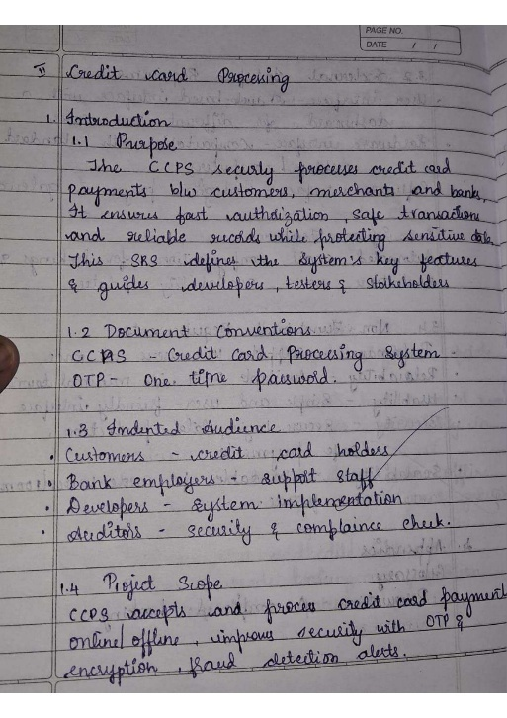 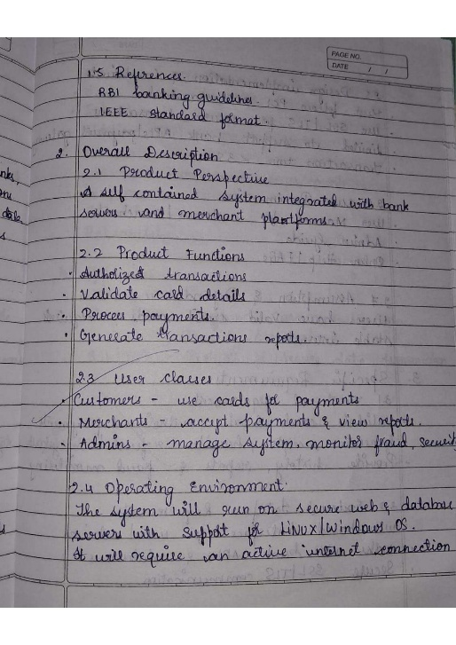 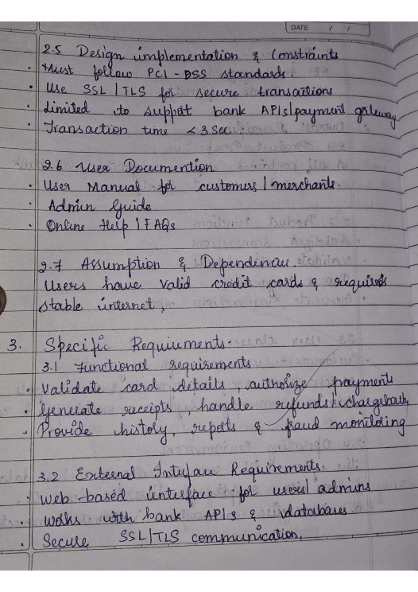 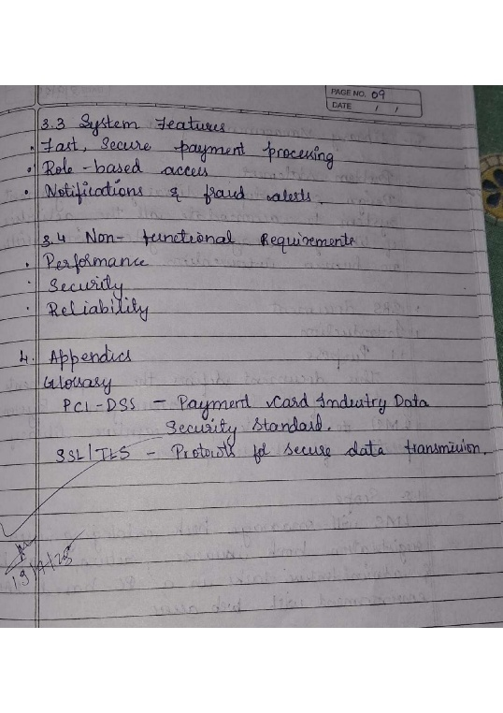

**Class diagram**

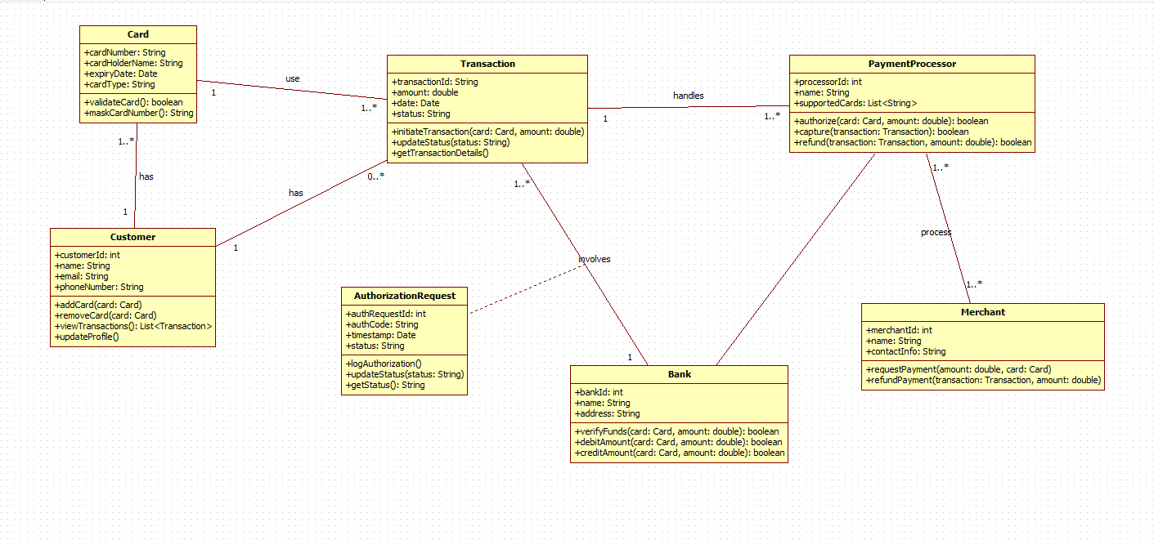

|  |  |  |  |
| --- | --- | --- | --- |
| **Class Name** | **Purpose / What It Does** | **Relationships** | **Explanation** |
| Card | Stores the card number, expiry, CVV, and validity status. Used to perform transactions. | Card → Transaction (uses) Card → Customer (belongs to) | A card belongs to one customer but can be used in many transactions. |
| Customer | Stores customer details and linked cards. Can view transactions and update profile. | Customer → Card (1 to many) Customer → Transaction (makes) | One customer can have multiple cards and can make many transactions. |
| Transaction | Represents a payment made using a card. Stores amount, date, and status. | Transaction → Card Transaction → Bank Transaction → PaymentProcessor Transaction → Merchant | A transaction involves a card, a bank, a merchant, and is handled by a processor. |
| AuthorizationRequest | Sends verification request to the bank before approving a transaction. | AuthorizationRequest → Bank (sent to) AuthorizationRequest → Transaction (belongs to) | A transaction generates at most one authorization request. |
| Bank | Verifies card validity, approves transactions, debits or credits accounts. | Bank → AuthorizationRequest Bank → Transaction | The bank approves or rejects transaction requests. |
| PaymentProcessor | Processes payments between card, merchant, and bank. Handles authorizations, captures, and refunds. | PaymentProcessor → Transaction PaymentProcessor → Merchant | The processor manages the flow of each transaction to the bank and merchant. |
| Merchant | Represents the business receiving payment. Requests payment and processes refunds. | Merchant → PaymentProcessor Merchant → Transaction | A merchant initiates transaction processing through a payment processor. |

**State Diagram:**

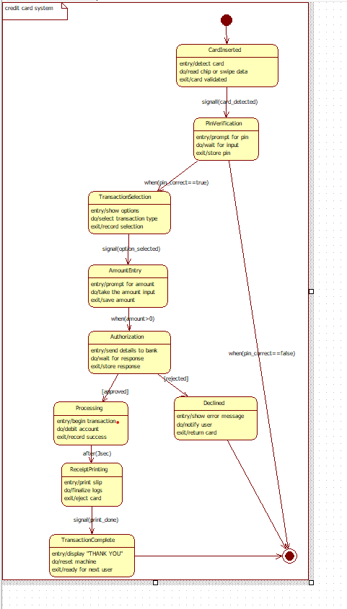

|  |  |  |  |  |
| --- | --- | --- | --- | --- |
| **State** | **Description** | **Trigger** | **Next State** | **Explanation** |
| CardInserted | Detects card and validates chip/magnetic data. | card_detected | PinVerification | First step when card is inserted. |
| PinVerification | Prompts for PIN and validates it. | pin_correct == true | TransactionSelection | User enters PIN. |
| TransactionSelection | Shows transaction options (withdrawal, balance, etc.). | option_selected | AmountEntry | User selects operation. |
| AmountEntry | User enters amount. | amount > 0 | Authorization | System prepares for authorization. |
| Authorization | Sends details to bank for approval. | approved | Processing | Bank approves or rejects. |
| Processing | Debits account and confirms transaction. | after(3 sec) | ReceiptPrinting | Actual transaction execution. |
| ReceiptPrinting | Prints slip and finalizes logs. | print_done | TransactionComplete | Final step before completion. |
| TransactionComplete | Displays thank you and resets machine. | — | End State | Process ends. |
| Declined | Shows error if PIN or bank check fails. | rejected | End | Alternative failure path. |

**Use-Case Diagram:**

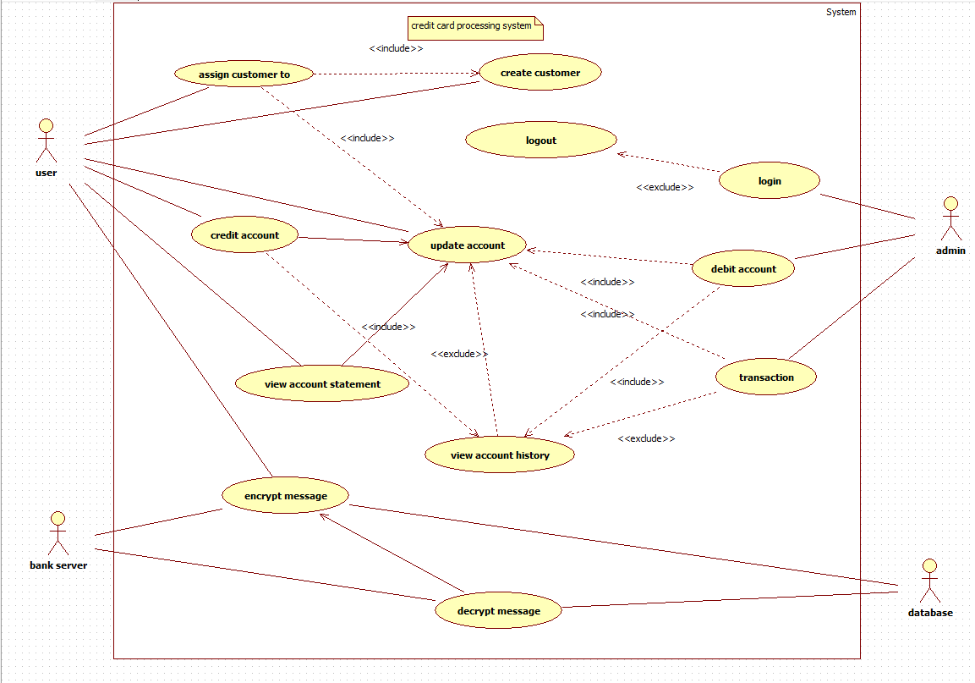

TABLE 1: Actors & Responsibilities

|  |  |
| --- | --- |
| **Actor** | **Responsibilities** |
| User (Customer) | Creates account, credits/debits account, views statements, encrypt/decrypt messages for secure transactions. |
| Admin | Manages login, creates customer accounts, updates/deletes account records, handles transactions. |
| Bank Server | Encrypts and decrypts sensitive messages, validates transactions. |
| Database | Stores account data, transaction history, login credentials. |

TABLE 2: Use Cases, Purpose, and Relationships

|  |  |  |  |  |
| --- | --- | --- | --- | --- |
| **Use Case** | **Purpose** | **Actor** | **Relationship** | **Explanation** |
| Assign customer to | Links a customer to account | User | Includes → Create customer | Customer creation may be required first. |
| Create customer | Registers new user | Admin | — | Admin adds customer to database. |
| Login | Admin or user logs in | Admin | Extends → Logout | After login, logout becomes available. |
| Logout | Ends the session | Admin | — | Ends active session. |
| Credit account | Adds funds to account | User | Includes → Update account | Updates logged account. |
| Debit account | Deducts money from account | User | Includes → Update account | Requires account update. |
| Update account | Modifies account balance or details | Admin / User | — | Central use case for all transactions. |
| View account statement | Shows recent transactions | User | Includes → View account history | Needs history data. |
| View account history | Shows complete transaction record | User | Extends (optional) | Called if statement needs detail. |
| Encrypt message | Secures message before sending | Bank server | — | Used for transaction security. |
| Decrypt message | Converts encrypted message back | Database | — | Data reading from secure source. |
| Transaction | Handles payment transfer | Admin | Included by debit/credit | Triggered during money operations. |

**Sequence diagram**

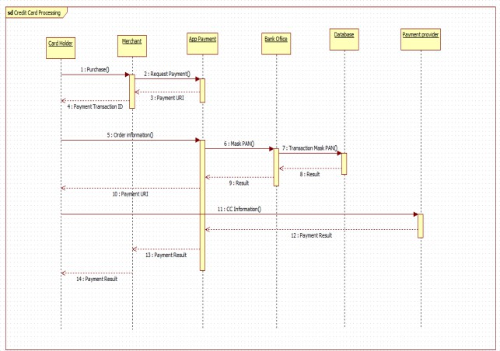

The sequence diagram shows the flow of a credit card payment from purchase to completion.

The Card Holder initiates a payment, the Merchant sends the request, and the App Payment system processes the order by masking card details and communicating with the Bank Office and Database for verification. After validation, the payment result is returned through the App Payment system to the Merchant, Payment Provider, and finally to the Card Holder.

**Acitivity diagram**

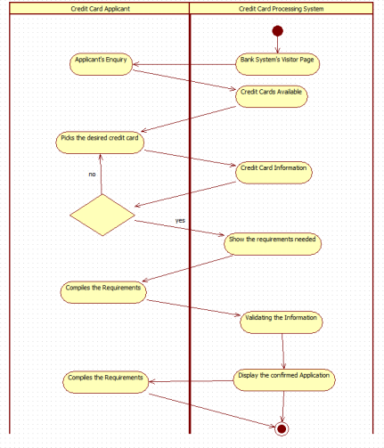

The activity diagram illustrates the process of a credit card applicant applying through the bank’s credit card processing system. The applicant sends an enquiry, views available credit cards, and selects one. The system displays the card information and required documents. After the applicant submits the necessary requirements, the system validates the information and finally

displays the confirmed application.

1. **. Library Management System**

**Problem statement :**

Traditional library management relies heavily on manual book issuance, record keeping, and fine calculation, which leads to errors, loss of data, and inefficiency during peak hours. Students and staff often face difficulty in finding books, checking availability, and tracking due dates. Therefore, an automated Library Management System is needed to streamline book cataloging, member registration, lending/return operations, and fine management. The system should provide quick search capabilities, maintain accurate inventory records, and improve overall library operations with reduced manual workload.

**SRS-Software Requirements Specification**

**1. Introduction**

**1.1 Purpose**

This document defines the functional and technical requirements for the Library Management System. It provides clear guidance for developers and stakeholders regarding the system’s expected features and constraints.

**1.2 Scope**

The system covers book cataloging, member registration, lending/return operations, fine calculation, searching, and reporting. It aims to digitalize library tasks and improve accuracy and efficiency.

**1.3 Overview**

The Library Management System replaces manual processes with automated workflows, enabling easy management of books, users, transactions, and inventory.

**2. General Description**

The system supports librarians, students, and administrators. It maintains a database of books, authors, categories, and member profiles. Features include borrowing rules, fine calculation, notifications, and inventory tracking. The system ensures quick searching and reduces workload.

**3. Functional Requirements**

**3.1 Book Catalog Management**

* Add, edit, delete, and categorize books.
* Maintain information such as title, author, ISBN, and availability.
* Track lost, damaged, or reserved books.

**3.2 Member Management**

* Register new members and store personal details.
* Track borrowing history and membership validity.
* Generate membership cards if needed.

**3.3 Lending & Return Management**

* Issue and return books with date tracking.
* Auto-calculate late fees and generate payment receipts.
* Display due date reminders to members.

**3.4 Search and Reporting**

* Search books by title, author, category, or ISBN.
* Generate daily transaction reports, inventory summaries, and user activity logs.

**4. Interface Requirements**

**4.1 User Interface**

* Clean dashboard for librarians with book inventory and member lists.
* Member portal for viewing borrowed books and due dates.
* Designed to be simple and user-friendly.

**4.2 Integration Interfaces**

* Barcode scanner integration for fast book issuing.
* Optional integration with online library portals.

**5. Performance Requirements**

* Searching books or members should take less than 2 seconds.
* Must support up to 500 users at the same time, including students and staff.
* Issuing and returning transactions should update instantly across modules.
* System should operate without lag even during semester peak days.

**6. Design Constraints**

* Should run on existing library computers with typical hardware specs.
* Requires a relational database like MySQL/PostgreSQL to store book records.
* Must support barcode scanners and optional RFID technology.
* Should function offline with local database access if internet is slow.

**7. Non-Functional Attributes**

Includes secure access, reliability for continuous operations, scalable database, easy UI navigation, cross-platform compatibility, modular design for reuse, and consistent data accuracy across modules.

**8. Schedule and Budget**

The project requires approximately 4–5 months with a budget of $40,000 for software development, database setup, and testing.

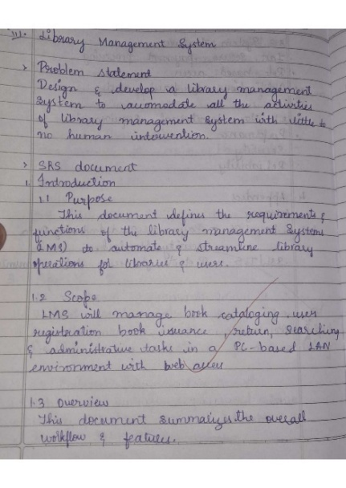 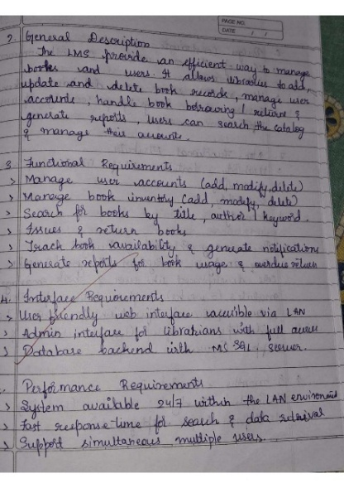 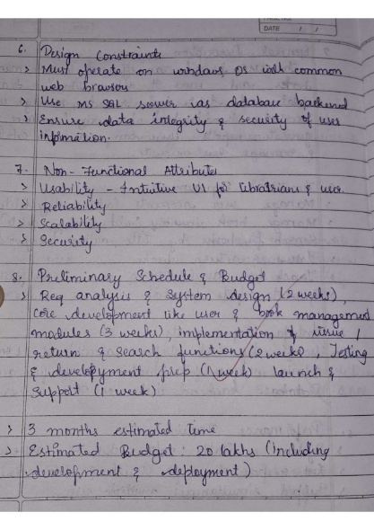

**Class diagram**

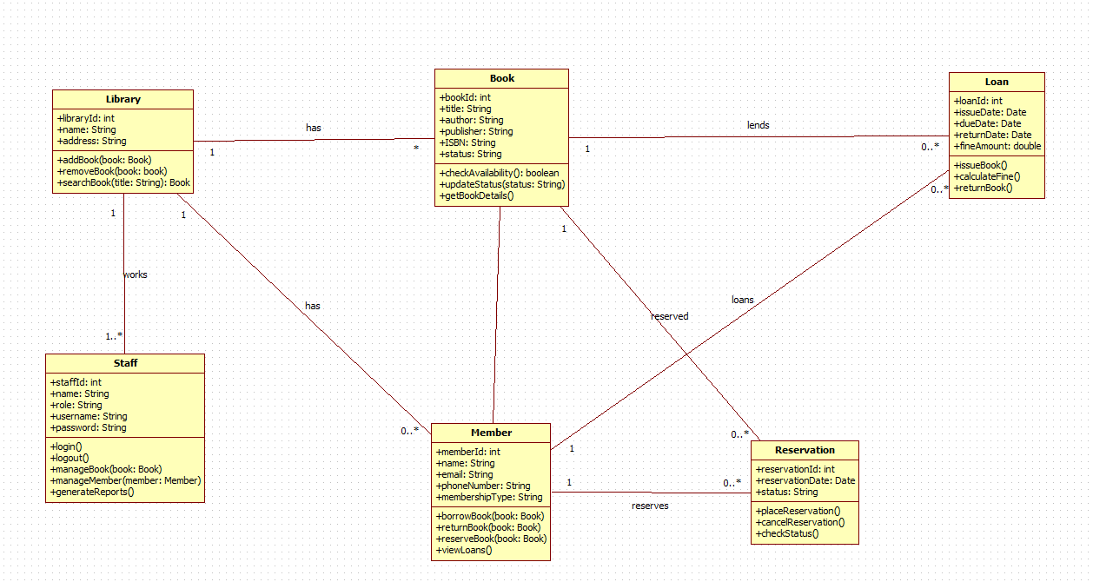

|  |  |  |  |
| --- | --- | --- | --- |
| **Class Name** | **Purpose** | **Relationships** | **Explanation** |
| Library | Contains library information and manages book inventory. | Library → Book (has) | One library contains many books. |
| Staff | Manages library operations, adds books, and generates reports. | Staff → Library (works for) | Staff works in a specific library. |
| Book | Holds book details such as title, author, ISBN, and availability. | Book → Loan (lent to) Book → Reservation (reserved by) Book → Library | One book can be loaned many times or reserved by members. |
| Member | Represents library members and their borrowed/reserved books. | Member → Loan (borrows) Member → Reservation (reserves) | A member can borrow multiple books and place multiple reservations. |
| Loan | Represents the borrowing of a book. Stores due date, issue date, and fines. | Loan → Member Loan → Book | One loan is created for one member and one book. |
| Reservation | Represents a book reserved by a member. | Reservation → Member Reservation → Book | One reservation links one book to one member. |

**State Diagram:**

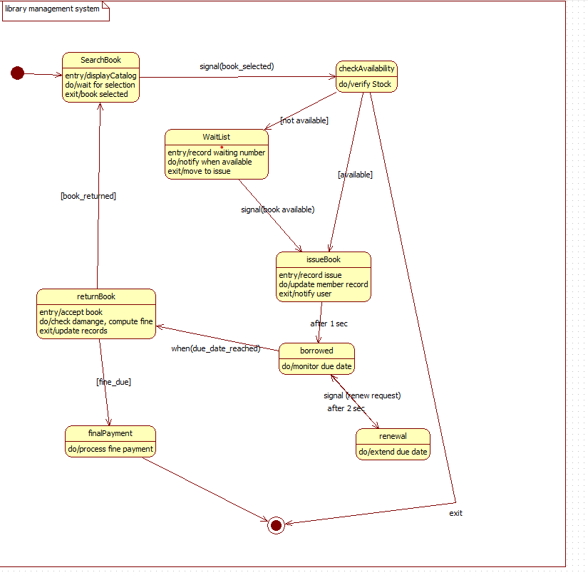

|  |  |  |  |  |
| --- | --- | --- | --- | --- |
| **State** | **Description** | **Trigger** | **Next State** | **Explanation** |
| SearchBook | User searches and selects a book. | book_selected | checkAvailability | First step of book issue. |
| checkAvailability | System checks if book is available. | available | issueBook | Availability determines next state. |
| WaitList | Records waiting number for unavailable books. | book_available | issueBook | User waits until book is returned. |
| issueBook | Issues book and updates records. | after(1 sec) | borrowed | Book issued to member. |
| borrowed | Member currently holds the book. | due_date_reached | returnBook | Borrowing period active. |
| returnBook | Accepts returned book and computes fines. | fine_due | finalPayment | Book returned. |
| finalPayment | Processes fine payments if needed. | — | Exit | Last step before exit. |
| renewal | Extends book borrowing time. | renew_request | borrowed | Optional extension path. |

**Use-Case Diagram:**

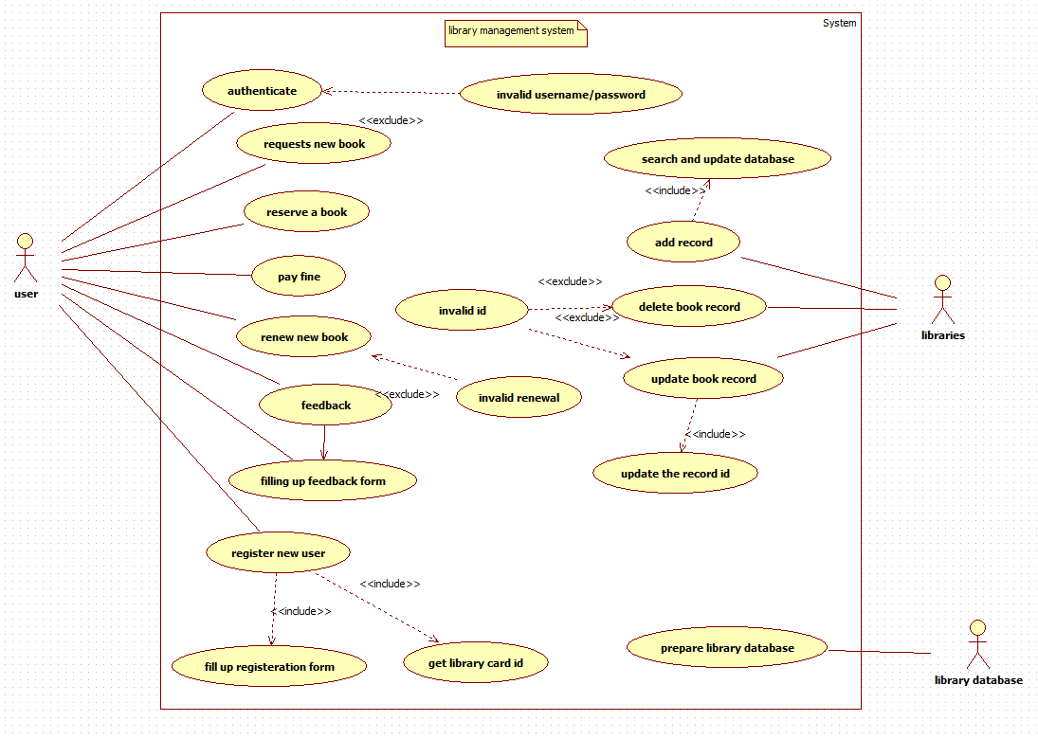

|  |  |
| --- | --- |
| **Actor** | **Description / Responsibilities** |
| User (Student/Member) | Authenticates into the system, reserves books, requests new books, renews books, pays fines, registers as new user, and submits feedback. |
| Libraries (Librarian) | Manages book records, updates database, adds books, deletes books, updates book information. |
| Library Database | Stores and maintains all books, users, and transaction records (system actor). |

|  |  |  |  |  |
| --- | --- | --- | --- | --- |
| **Use Case** | **Purpose / What It Does** | **Actor** | **Relationship** | **Explanation** |
| Authenticate | Verifies username and password | User | Extends → Invalid username/password | If authentication fails, invalid message displays. |
| Request new book | User requests a new book to be added | User | — | Sent to library staff for processing. |
| Reserve a book | Reserves an available book | User | — | Regular book reservation. |
| Pay fine | Pays overdue fine | User | — | Triggered after return processing. |
| Renew new book | Extends borrowing period | User | Extends → Invalid renewal | Renewal may fail if due date passed. |
| Feedback | Provides comments or suggestions | User | Includes → Fill feedback form | Feedback needs form filling. |
| Fill feedback form | Submits detailed feedback | User | Included | Always part of feedback. |
| Register new user | Creates a new member account | User | Includes → Fill registration form | Registration requires filling user details. |
| Fill registration form | Captures user details | User | Included | Required for new user creation. |
| Get library card ID | Generates card ID for new user | User | Included | Follows registration. |
| Invalid ID | Displays error if book ID incorrect | User | Extends Book update/delete | Shown only when ID mismatch. |
| Search and update database | Searches books and updates data | Libraries | Includes → Add record / Update book record | Required for modifying library records. |
| Add record | Adds new book to system | Libraries | — | Part of managing library. |
| Update book record | Updates existing book info | Libraries | Includes → Update record ID | Requires ID validation. |
| Delete book record | Deletes selected book | Libraries | Extends → Invalid ID | Deletion fails if ID invalid. |
| Prepare library data | Prepares master book file | Library database | — | Back-end system processing. |

**Sequence diagram**

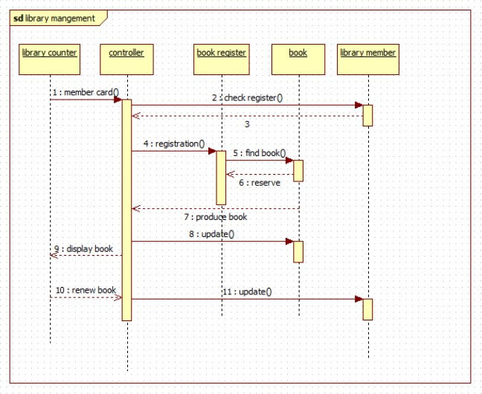

The sequence diagram shows the process of managing book transactions in a library. A library member presents their card at the library counter, which triggers the controller to check the book register, register the member, and search for the requested book. Once the book is found and reserved, it is produced for the member. The system updates the book’s status, displays it to the member, and also handles book renewal requests, updating the records accordingly.

**Acitivity diagram**

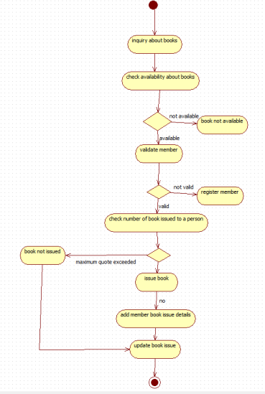

The activity diagram outlines the process of issuing a book in a library. It begins with a user inquiring about a book and checking its availability. If available, the system validates the member; if not registered, the member is asked to register. The system then checks whether the member has exceeded the maximum number of issued books. If eligible, the book is issued, the member’s issue details are added, and the book issue record is updated. Otherwise, the book is not issued.

1. **. Stock Maintenance System**

**Problem statement :**

Businesses often struggle to maintain accurate stock details, record stock movements, track damaged goods, and ensure timely replenishment due to manual monitoring methods. This leads to inconsistencies, loss of inventory, and delays in decision-making. A Stock Maintenance System is required to efficiently record stock entries, monitor stock levels, track item conditions, update stock usage, and generate maintenance logs. The system should help staff maintain accurate inventory records, reduce manual errors, and support smooth operational flow.

**SRS-Software Requirements Specification**

**1. Introduction**

**1.1 Purpose**

The purpose of this SRS is to define the functional and non-functional requirements of the Stock Maintenance System. It ensures that developers, testers, and stakeholders understand the system goals, behavior, and technical expectations.

**1.2 Scope**

The system covers stock entry management, updating stock usage, tracking damaged/expired goods, generating stock maintenance reports, and sending low-stock alerts. It supports warehouse staff, store managers, and administrators.

**1.3 Overview**

The Stock Maintenance System helps businesses keep accurate stock records by automating the monitoring and updating of inventory details. It reduces manual errors, improves stock visibility, and ensures timely maintenance actions.

**2. General Description**

The system is used by warehouse workers, store managers, and admin staff to manage stock quantities, condition status, and movement history. It stores item details, consumption patterns, stock condition reports, and maintenance logs. The system ensures up-to-date stock information and provides alerts for low or damaged items to help prevent shortages or wastage.

**3. Functional Requirements**

**3.1 Stock Entry Management**

* Allows adding new stock items with details like name, category, quantity, and condition.
* Supports editing and deleting stock entries.
* Maintains purchase date and supplier information.

**3.2 Stock Usage Updating**

* Reduces quantities when items are issued or consumed.
* Maintains usage logs for tracking consumption history.
* Allows returned or unused stock updates.

**3.3 Damage & Expiry Tracking**

* Marks items as damaged, expired, or unavailable.
* Stores reason codes and timestamps for all damaged entries.
* Supports separate listing for unusable stock.

**3.4 Low-Stock Alerts**

* Sends alerts when stock falls below minimum threshold.
* Helps managers plan timely reordering.

**3.5 Reporting**

* Generates daily, weekly, or monthly stock maintenance reports.
* Provides summaries for damaged, consumed, and available stock.

**4. Interface Requirements**

**4.1 User Interface**

* Simple dashboard displaying total stock, low-stock items, and damaged items.
* Easy-to-use forms for adding or updating stock.
* Supports search and filter options for fast navigation.

**4.2 Integration Interfaces**

* Supports barcode scanners for item entry.
* Can integrate with accounting or purchase order systems if required.

**5. Performance Requirements**

* Updates to stock quantities must reflect in real time.
* Should handle 200+ stock updates per hour without delay.
* System responses (search, update, add) should be under 2 seconds.
* Must maintain accuracy even with large stock volumes (10,000+ items).

**6. Design Constraints**

* Must support existing store hardware like barcode readers and standard computers.
* Requires a stable relational or NoSQL database for large inventory sets.
* Must run on commonly used OS (Windows/Linux) and support major browsers.
* Should support periodic backup to prevent data loss.

**7. Non-Functional Attributes**

* **Security:** Role-based access for staff and admin.
* **Reliability:** Should operate continuously with minimal downtime.
* **Scalability:** Able to manage increasing stock items in the future.
* **Usability:** Interfaces must be simple for fast entry operations.
* **Portability:** Should run on desktops, laptops, and web-based systems.
* **Reusability:** Modular design for adding new inventory features.
* **Compatibility:** Works with barcode scanners, POS, and web browsers.
* **Data Integrity:** Ensures correct and consistent stock data at all times.

**8. Schedule and Budget**

Estimated development time is 5–6 months including design, implementation, testing, and deployment. The expected budget is $70,000, covering database design, UI development, system integration, testing, and maintenance support.

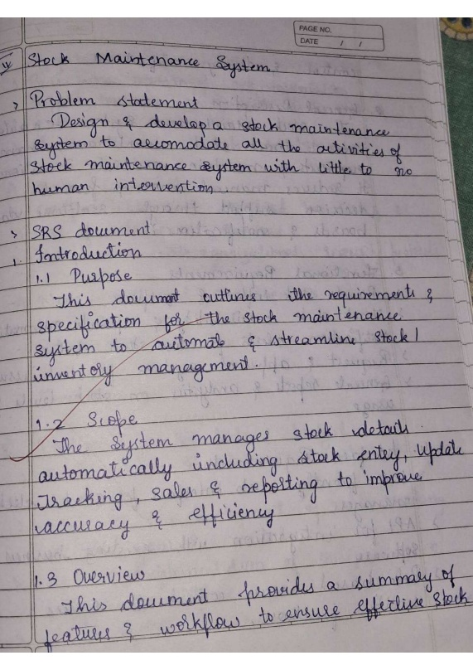 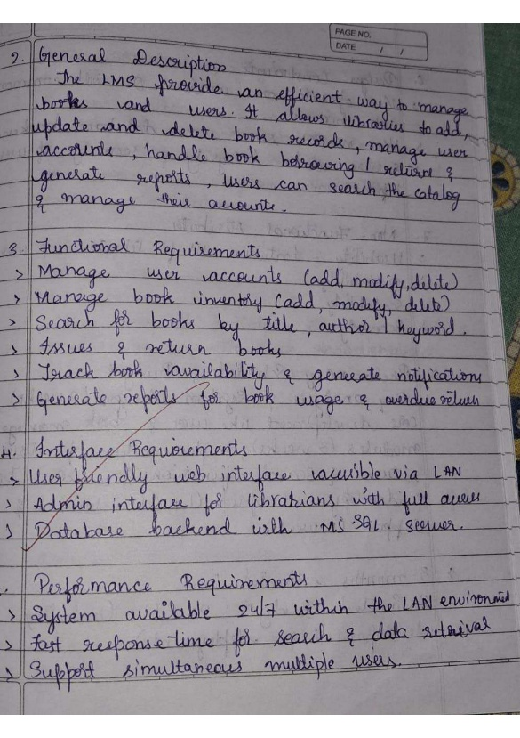

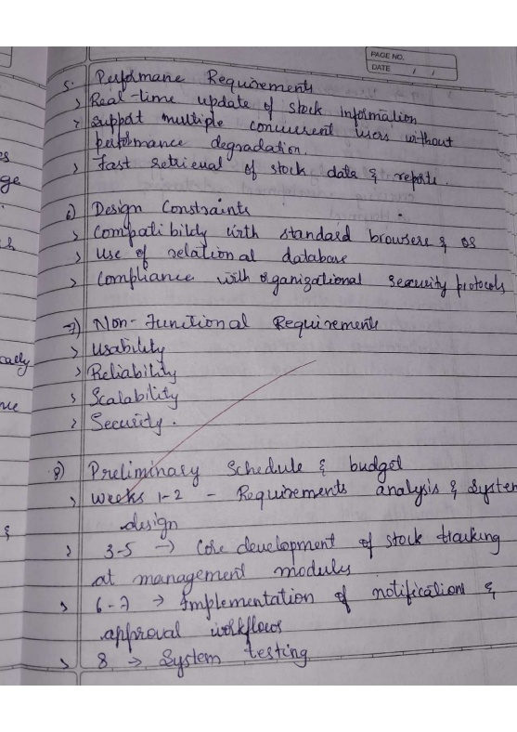 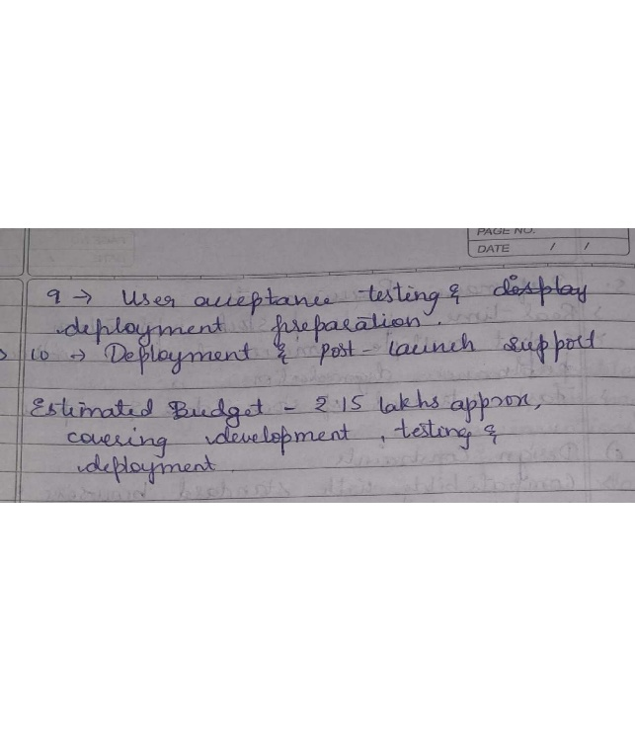

**Class diagram**

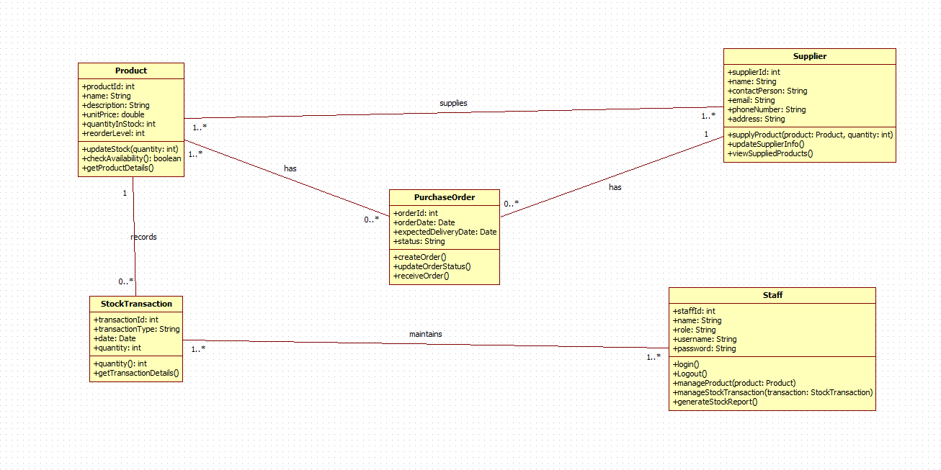

|  |  |  |  |
| --- | --- | --- | --- |
| **Class Name** | **Purpose** | **Relationships** | **Explanation** |
| Product | Stores product details like name, price, quantity, and reorder level. | Product → PurchaseOrder (ordered via) Product → StockTransaction | Each product can be included in multiple orders and stock transactions. |
| Supplier | Holds supplier details and provides products. | Supplier → PurchaseOrder (supplies) | A supplier supplies many purchase orders. |
| PurchaseOrder | Represents product orders sent to suppliers. | PurchaseOrder → Product PurchaseOrder → Supplier | One order can contain multiple products and is assigned to one supplier. |
| StockTransaction | Records stock in/out movements. | StockTransaction → Product StockTransaction → Staff | A stock transaction updates product quantity and is recorded by staff. |
| Staff | Maintains stock records and generates reports. | Staff → StockTransaction Staff → PurchaseOrder | Staff manages order creation and stock transactions. |

**State Diagram:**

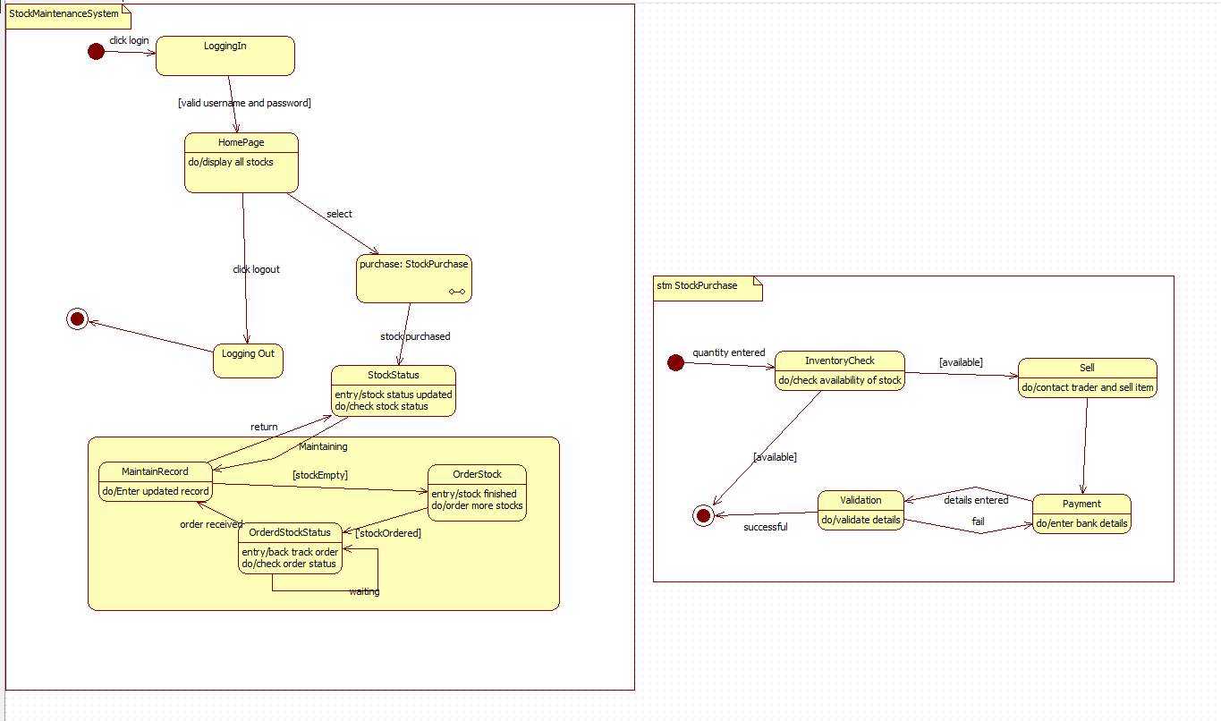

|  |  |  |  |  |
| --- | --- | --- | --- | --- |
| **State** | **Description** | **Trigger** | **Next State** | **Explanation** |
| LoggingIn | Validates credentials. | valid username/password | HomePage | User logs into the system. |
| HomePage | Displays all stock and menu options. | purchase: StockPurchase | StockPurchase | Main dashboard. |
| LoggingOut | Clears session and logs user out. | logout | End | User exits the system. |
| StockStatus | Updates stock information. | stockPurchased | MaintainRecord | System updates after purchase. |
| MaintainRecord | Records updated stock details. | stockEmpty | OrderStock | Handles stock records. |
| OrderStock | Places purchase order for low stock. | stockOrdered | OrderStockStatus | Stock order initiated. |
| OrderStockStatus | Tracks order status. | order_received | MaintainRecord | Monitor arrival of ordered stock. |

|  |  |  |  |  |
| --- | --- | --- | --- | --- |
| **State** | **Description** | **Trigger** | **Next State** | **Explanation** |
| InventoryCheck | Checks if stock available for sale. | available | Sell | First validation step. |
| Sell | Contacts trader and sells goods. | — | Payment | Item sold. |
| Payment | Enters payment/bank details. | details entered | Validation | Payment information processed. |
| Validation | Confirms transaction details. | available | Success | Final confirmation. |

**Use-Case Diagram:**

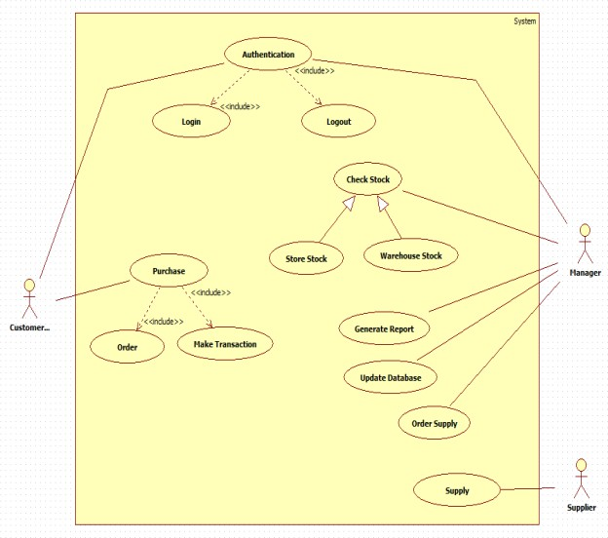

|  |  |
| --- | --- |
| **Actor** | **Responsibilities** |
| Staff | Manages stock, updates records, purchases stock, checks stock status, logs into system. |
| Supplier | Receives purchase orders and delivers stock. |
| Trader (System Actor) | Used in the StockPurchase sub-process (for selling). |

|  |  |  |  |  |
| --- | --- | --- | --- | --- |
| **Use Case** | **Purpose** | **Actor** | **Relationship** | **Explanation** |
| Logging in | Authenticates staff | Staff | — | Entry point for system. |
| HomePage | Shows stock options | Staff | — | Main menu. |
| Logout | Ends user session | Staff | — | Exit action. |
| Purchase: StockPurchase | Starts stock buying workflow | Staff | — | Leads to sub-state machine. |
| StockStatus | Updates status of stock | Staff | — | Triggered after purchase. |
| MaintainRecord | Updates stock details | Staff | — | Manual corrections or updates. |
| OrderStock | Places new order | Staff | — | Triggered when stock empty. |
| OrderStockStatus | Tracks order state | Staff | Extends OrderStock | Optional repeated checking. |
| InventoryCheck | Checks if stock available | Staff | — | Part of StockPurchase flow. |
| Sell | Sells stock to trader | Staff | — | Sub-process step. |
| Payment | Processes payment for stock | Staff | — | Needed for transaction. |
| Validation | Confirms final details | Staff | — | Ends purchase workflow. |

**Sequence diagram**

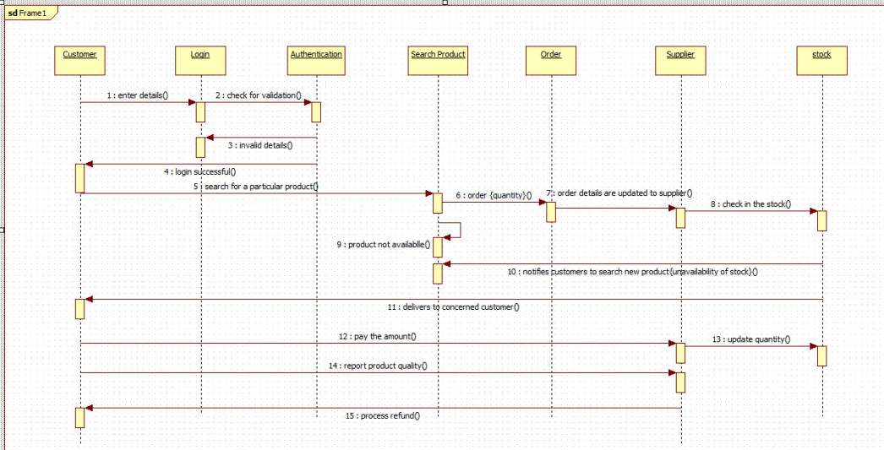

The sequence diagram illustrates the workflow of an online product ordering system. A customer logs in, searches for a product, and places an order. The system forwards order details to the supplier, who checks stock availability. If the product is unavailable, the system notifies the customer. If available, the supplier delivers the product, the customer makes the payment, and stock levels are updated. The customer may also report product quality, after which the system

processes a refund if required.

**Acitivity diagram**

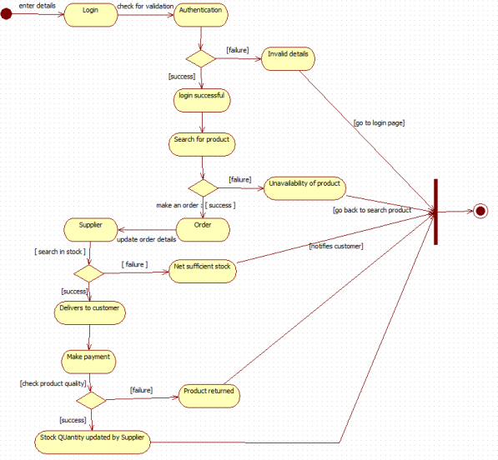

The activity diagram shows the workflow of an online product purchase process. The customer logs in and is authenticated; if valid, they search for a product and place an order. The supplier

checks stock availability and updates order details. If stock is sufficient, the product is delivered, payment is made, and product quality is checked. If the product fails the quality check, it is returned; if successful, stock quantity is updated. Invalid login or unavailable products redirect

the user back to the appropriate steps.

1. **Passport Automation System**

**Problem statement :**

Manual passport application and processing procedures are often time-consuming, prone to human errors, and require applicants to repeatedly visit passport offices for verification and documentation. This results in delays, inefficient document handling, and difficulty in tracking application status. Therefore, a Passport Automation System is required to streamline passport application submission, document verification, appointment scheduling, fee payment, and status tracking. The system should automate workflow steps, reduce manual intervention, improve accuracy, and provide applicants with a transparent and user-friendly experience.

**SRS-Software Requirements Specification**

**1. Introduction**

**1.1 Purpose**

This SRS document defines the requirements for a Passport Automation System that simplifies the passport application process. It ensures a clear understanding among developers and stakeholders regarding system functions such as application submission, appointment booking, verification, payment, and status tracking.

**1.2 Scope**

The system enables applicants to submit applications online, upload supporting documents, schedule verification appointments, make online fee payments, and track passport status. It also supports government officials in verifying documents, updating application status, and managing approvals.

**1.3 Overview**

The Passport Automation System improves efficiency by replacing manual paperwork with a centralized digital platform. The system reduces processing time, minimizes human error, and provides greater transparency throughout the application lifecycle.

**2. General Description**

The system is intended for applicants, passport office staff, and administrators. Applicants can fill forms online, upload documents, pay fees, and check status updates. Officers can verify applications, approve or reject submissions, and schedule processing tasks. The system ensures smooth coordination between different passport processing stages and maintains accurate records for auditing.

**3. Functional Requirements**

**3.1 Application Submission**

* Allows applicants to fill in online passport forms.
* Uploads identity proofs, address proofs, and photographs.
* Validates mandatory fields and document formats.

**3.2 Appointment Scheduling**

* Enables applicants to choose a preferred date and time for verification.
* Automatically assigns passport office counters based on availability.
* Sends SMS/email appointment confirmations.

**3.3 Document Verification**

* Passport officers review uploaded documents.
* Officers update status as “Approved,” “Pending,” or “Rejected.”
* Supports internal comments for follow-up or clarification.

**3.4 Fee Payment**

* Supports online payments through UPI, credit/debit cards, and net banking.
* Generates transaction receipts and billing records.

**3.5 Status Tracking**

* Applicants can track real-time status: Submitted → Under Verification → Police Verification → Printing → Dispatched.
* Sends notifications when status changes.

**3.6 Reporting**

* Officers and admins can generate reports for daily applications, approvals, rejections, and pending verifications.

**4. Interface Requirements**

**4.1 User Interface**

* Simple, accessible interface for applicants with clear navigation for forms and uploads.
* Officer dashboard displaying pending applications, verifications, and status updates.
* Mobile-compatible interface for easy access.

**4.2 Integration Interfaces**

* Integration with payment gateways for fee processing.
* Integration with police verification system for background checks.
* Integration with national ID databases (Aadhaar, PAN) for identity matching.

**5. Performance Requirements**

* The system must handle high traffic, especially during seasonal application periods.
* Application form submission should respond within 3 seconds.
* Should support at least 3000 concurrent users.
* Status updates should reflect instantly across modules.

**6. Design Constraints**

* Must comply with national data privacy and security regulations.
* Should run on government servers and support restricted network environments.
* Requires OCR support for reading uploaded IDs (optional).
* Must use a reliable relational database for storing application data.

**7. Non-Functional Attributes**

* Security: Encrypted data, secure logins, role-based access.
* Reliability: Continuous operation with backup and recovery options.
* Scalability: Should support growing applicant numbers.
* Usability: User-friendly forms and document upload interface.
* Portability: Web-based, accessible from browsers and mobile devices.
* Reusability: Modular components for future passport services.
* Compatibility: Works across standard browsers and government systems.
* Data Integrity: Ensures accurate and consistent record management.

**8. Schedule and Budget**

The project development timeline is estimated at 6–7 months including analysis, design, development,

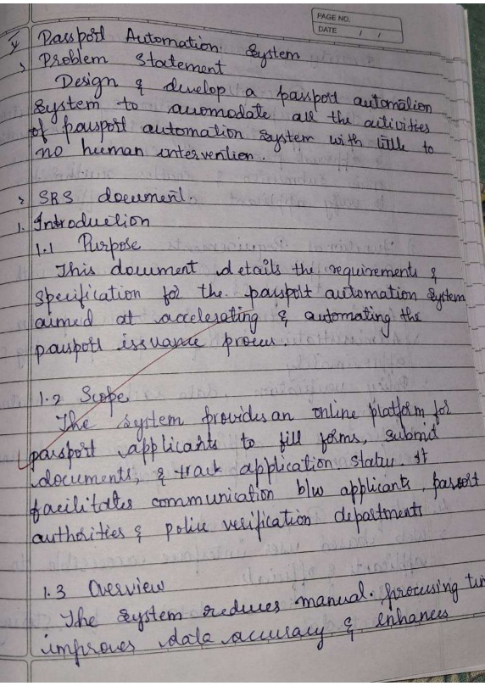 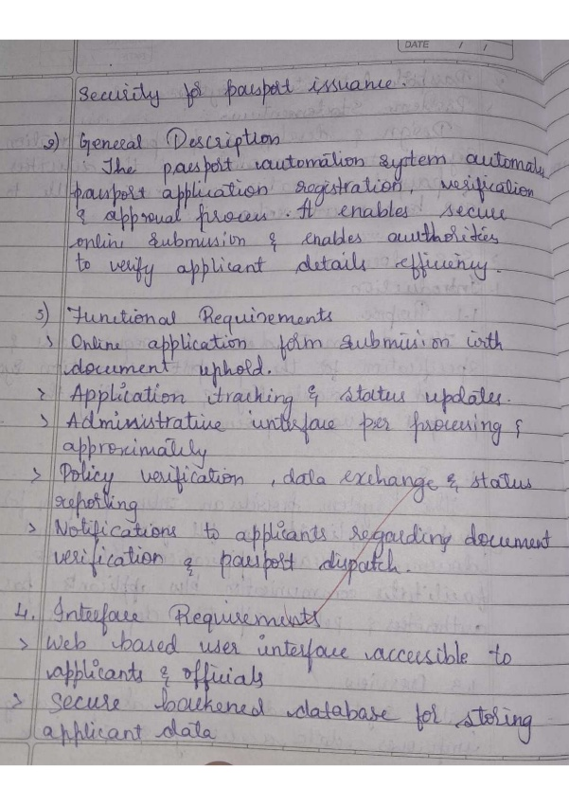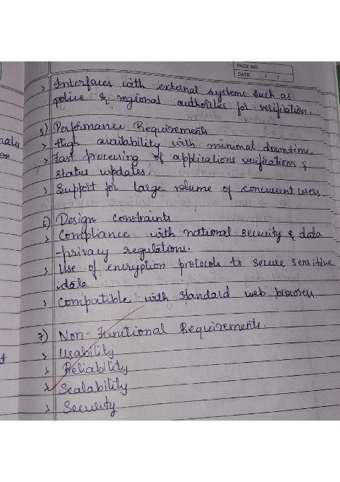 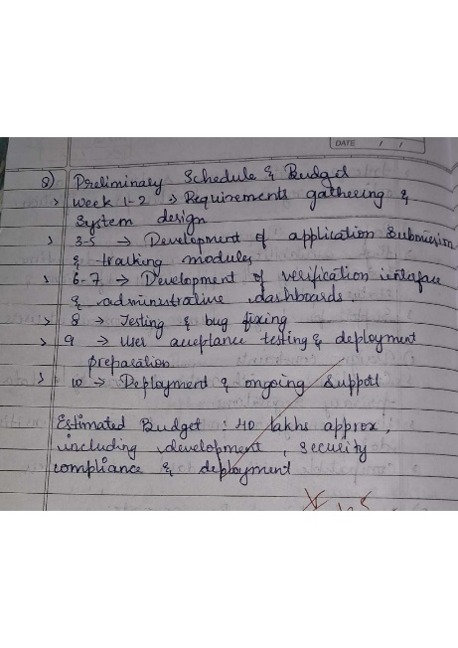

**Class diagram**

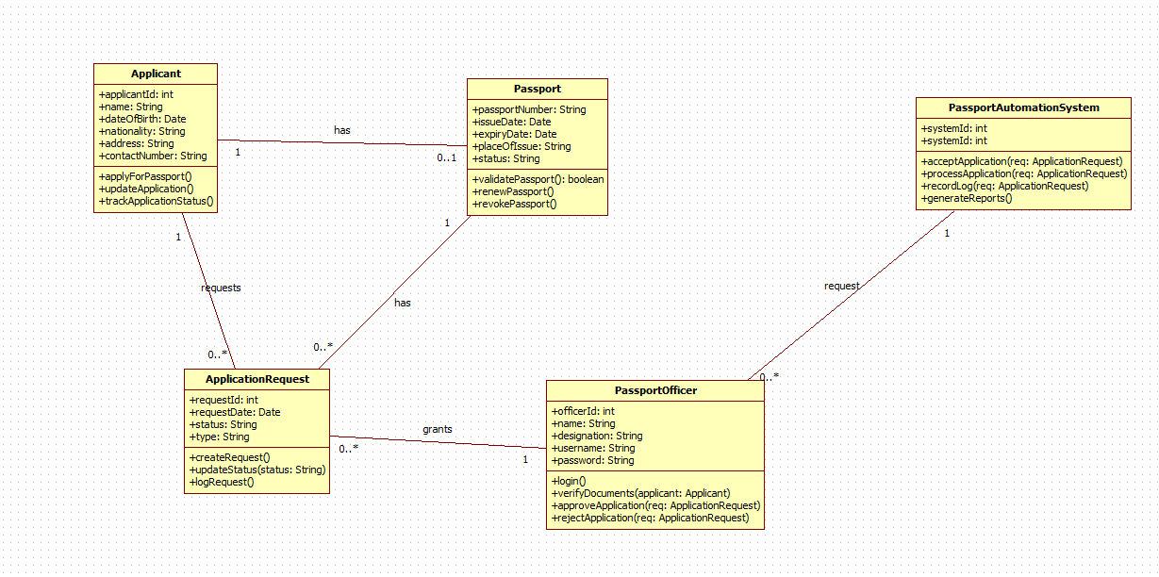

|  |  |  |  |
| --- | --- | --- | --- |
| **Class Name** | **Purpose** | **Relationships** | **Explanation** |
| Applicant | Stores applicant information and manages passport applications. | Applicant → ApplicationRequest Applicant → Passport | One applicant can submit multiple requests and have a passport. |
| Passport | Stores passport details such as issue/expiry date and status. | Passport → Applicant Passport → ApplicationRequest | One passport belongs to an applicant and is created after request approval. |
| ApplicationRequest | Handles the request for a new passport or renewal. | ApplicationRequest → Applicant ApplicationRequest → PassportOfficer | One applicant can submit many requests; each request is handled by one officer. |
| PassportOfficer | Verifies documents, approves or rejects applications. | PassportOfficer → ApplicationRequest | Officers validate each application request. |
| PassportAutomationSystem | Coordinates application submission, verification, and reporting. | System → ApplicationRequest | The system receives and manages all application requests. |

**State Diagram:**

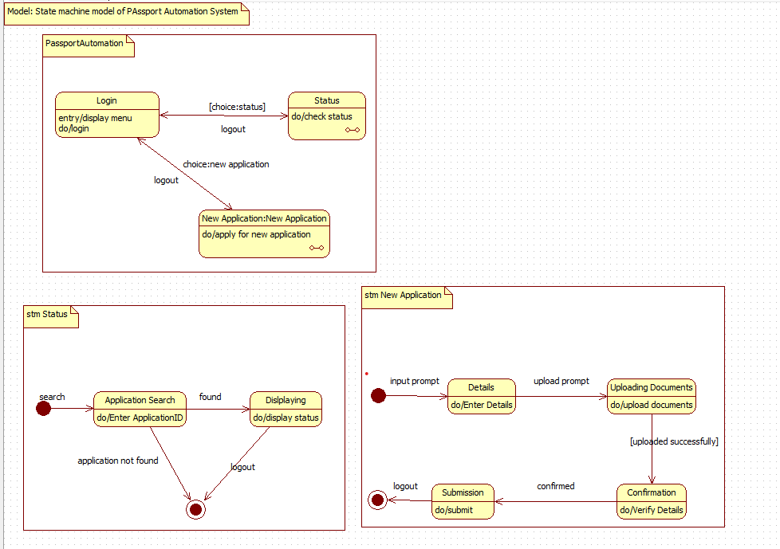

|  |  |  |  |  |
| --- | --- | --- | --- | --- |
| **State** | **Description** | **Trigger** | **Next State** | **Explanation** |
| Login | User logs into system and views menu. | choice:status | Status | First interaction. |
| Status | Checks application status. | logout | Login | User views current passport progress. |
| New Application | User applies for new passport. | choice:new application | New Application Flow | Moves to application submission. |

|  |  |  |  |  |
| --- | --- | --- | --- | --- |
| **State** | **Description** | **Trigger** | **Next State** | **Explanation** |
| Application Search | User enters application ID. | found | Displaying | First step for status check. |
| Displaying | Shows application status to user. | logout | End | Status displayed. |

|  |  |  |  |  |
| --- | --- | --- | --- | --- |
| **State** | **Description** | **Trigger** | **Next State** | **Explanation** |
| Details | User enters basic personal information. | upload prompt | Uploading Documents | First step of new passport. |
| Uploading Documents | User uploads required documents. | uploaded successfully | Confirmation | Document verification step. |
| Confirmation | System verifies data and documents. | confirmed | Submission | Validation phase. |
| Submission | Final submission and ID generation. | logout | End | Completes application. |

**Use-Case Diagram:**

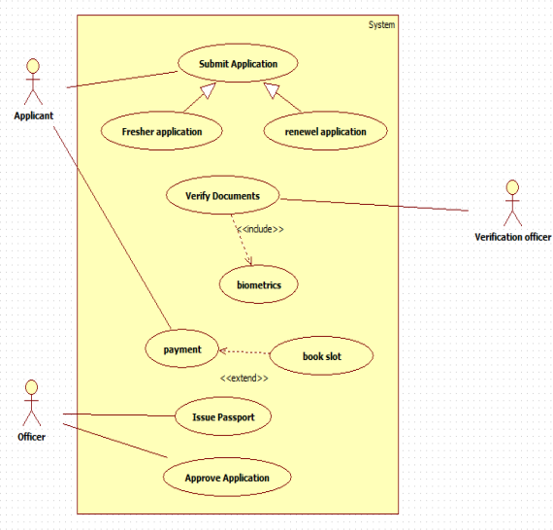

|  |  |
| --- | --- |
| **Actor** | **Responsibilities** |
| Applicant | Logs in, checks status, applies for new passport, submits documents. |
| Passport Officer | Reviews applications, verifies documents, approves/rejects. |
| System | Stores details, processes applications, shows status. |

|  |  |  |  |  |
| --- | --- | --- | --- | --- |
| **Use Case** | **Purpose** | **Actor** | **Relationship** | **Explanation** |
| Login | Applicant logs into system | Applicant | — | Starting point of use. |
| Status | Shows passport application status | Applicant | — | Called after login when checking progress. |
| New Application | Starts new passport request | Applicant | Includes → Details, Upload Documents, Confirmation, Submission | New application process has multiple mandatory steps. |
| Application Search | Searches application by ID | Applicant | Extends Status | Optional when user wants to see status. |
| Details | Enters personal information | Applicant | Included | Mandatory part of new application. |
| Upload Documents | Uploads ID proof, address proof | Applicant | Included | Required to complete application. |
| Confirmation | System verifies details | System | Included | Automatic verification stage. |
| Submission | Final submission | Applicant | Included | Final step in new application. |
| Logout | Ends session | Applicant / Officer | — | Optional action. |

**Sequence diagram**

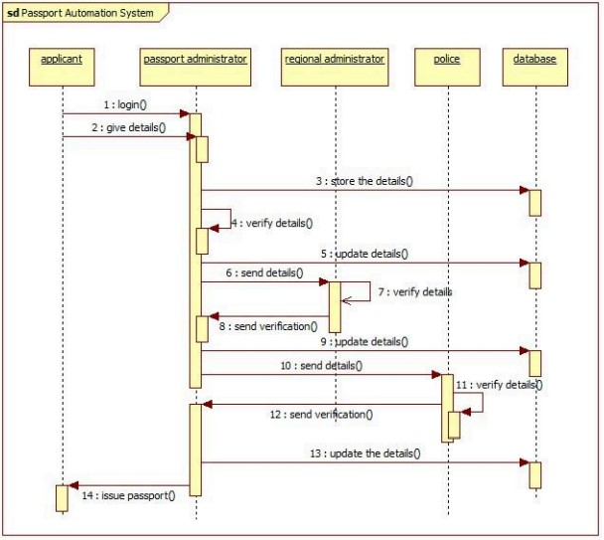

The sequence diagram shows the workflow of a passport automation system. The applicant logs in and submits details, which the passport administrator stores in the database. The regional administrator and police department sequentially verify the submitted information and update the records. After receiving verification from both authorities, the passport administrator issues the passport to the applicant.

**Acitivity diagram**

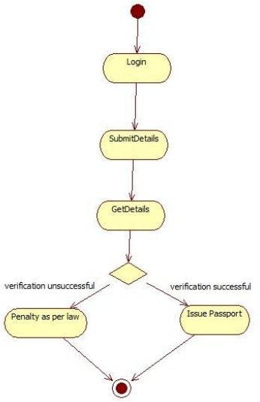

The activity diagram shows a simple passport verification process. A user logs in, submits their details, and the system retrieves and checks the information. If verification is successful, a passport is issued; if verification fails, a legal penalty is applied. The process then ends.